Exercise 6

Write a Java program that meets the following requirements.

1. Class name is Exercise6
2. File name is Exercise6.java
3. The program should declare a main method.
   1. In the main method the program should implement the logic to calculate the square root of a given number. Implement the logic of the given activity diagram.

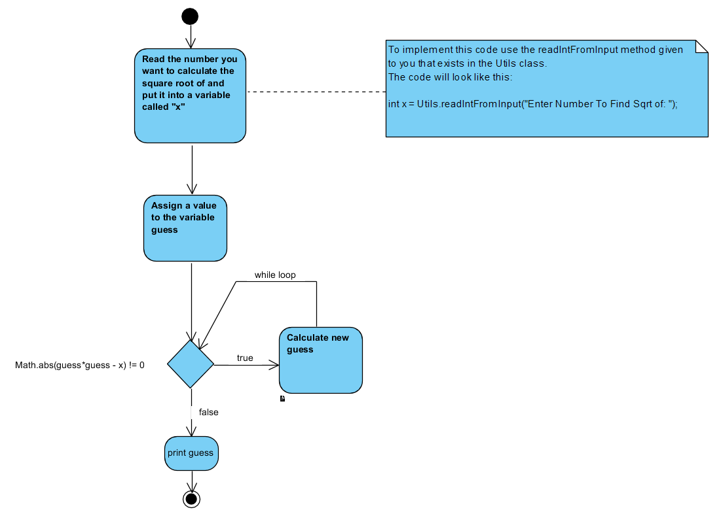

1. To calculate a new guess use the formula:

guess = (guess + x/guess)/2;

1. Your code must use a while loop.
2. Your code must use the class Utils.java to get the number from the user (see diagram). This class is given to you and is downloadable on learn.cnm.edu ->learning modules -> week 3. To use the Utils.java class all you have to do is download it and put it into the same directory as your Exercise6.java class. The Utils.java class will automatically get compiled when you compile Exercise6.java
3. The condition used in the while loop above works for numbers that have a perfect square, e.g. 25, 100, 9. But it does not work for finding the square root of other numbers, e.g. 99. For 10pts extra credit change the loop condition to find the the square root of all numbers.
4. NOTES:
   1. Compile your code with the command: javac Exercise6.java
   2. Execute your code with the command: java Exercise6
   3. Your code should prompt the user for a number to find the square root of. The code will not continue until the user enters a number and hits enter.

Test your code with entering multiple values. For example, the output of your code might be:

Enter Number To Find Sqrt of: 25

guess = 5.0

Enter Number To Find Sqrt of: 100

guess = 10.0

Use this code below as a framework for Exercise 6, i.e. copy this code below to get you stared.

**public** **class** Exercise6 {

**public** **static** **void** main(String[] args) {

**int** x = Utils.*readIntFromInput*("Enter Number To Find Sqrt of: ");

**float** guess = 3f;

//your algorithm here to calculate square root

System.***out***.println("guess = "+guess);

}

}